1.

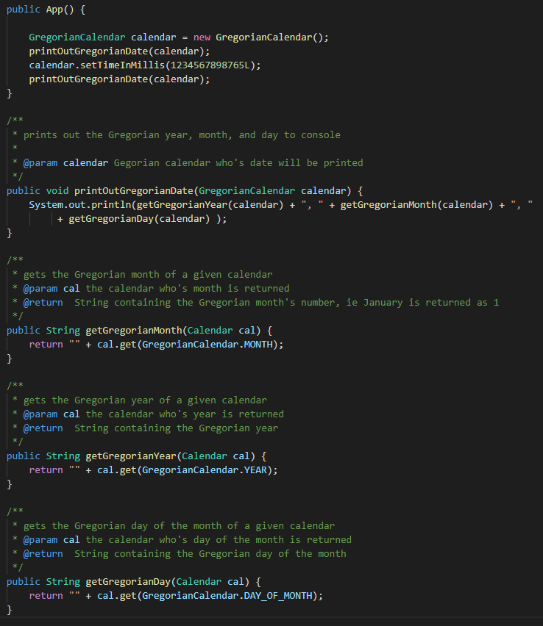



2.

find1

find4

*None, any w/ error*

*Once, any*

*1orMore, any*

*1orMore, lowest*

findStronger2

findStronger3

3.

Yes, the program will complain because you’re trying to access a private variable outside the class. You would need to implement a get method for the radius and use that in place of the myCircle.radius.

4.

Spec A has the weakest precondition out of the three and has the same postcondition as spec B. Spec A is stronger as such and ends up being the strongest of the three as C always returns true making it useless.

Spec B has a much stronger precondition than Spec A and weaker one than Spec C. The postcondition of Spec B is also tied with for the strongest, with A having the same one. This is the second strongest of the three conditions when allowing C to be ignored considering its nonsensical and not useful.

Spec C has the strongest precondition and the weakest postcondition making it the worst specification out of the three.